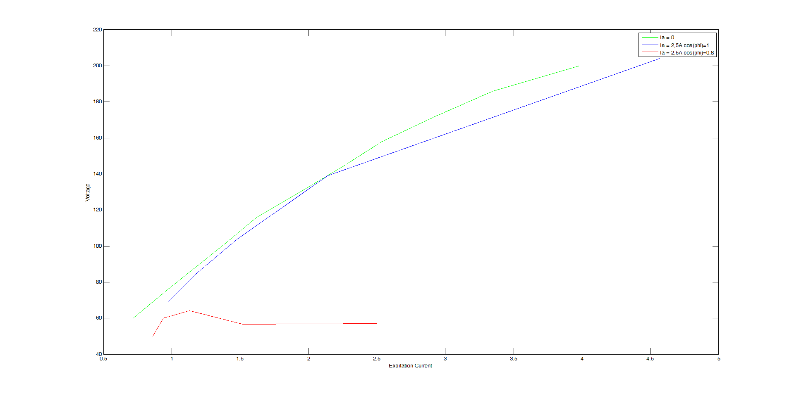

Fig. 1: No load and Loaded Curves of a Synchronous Generator

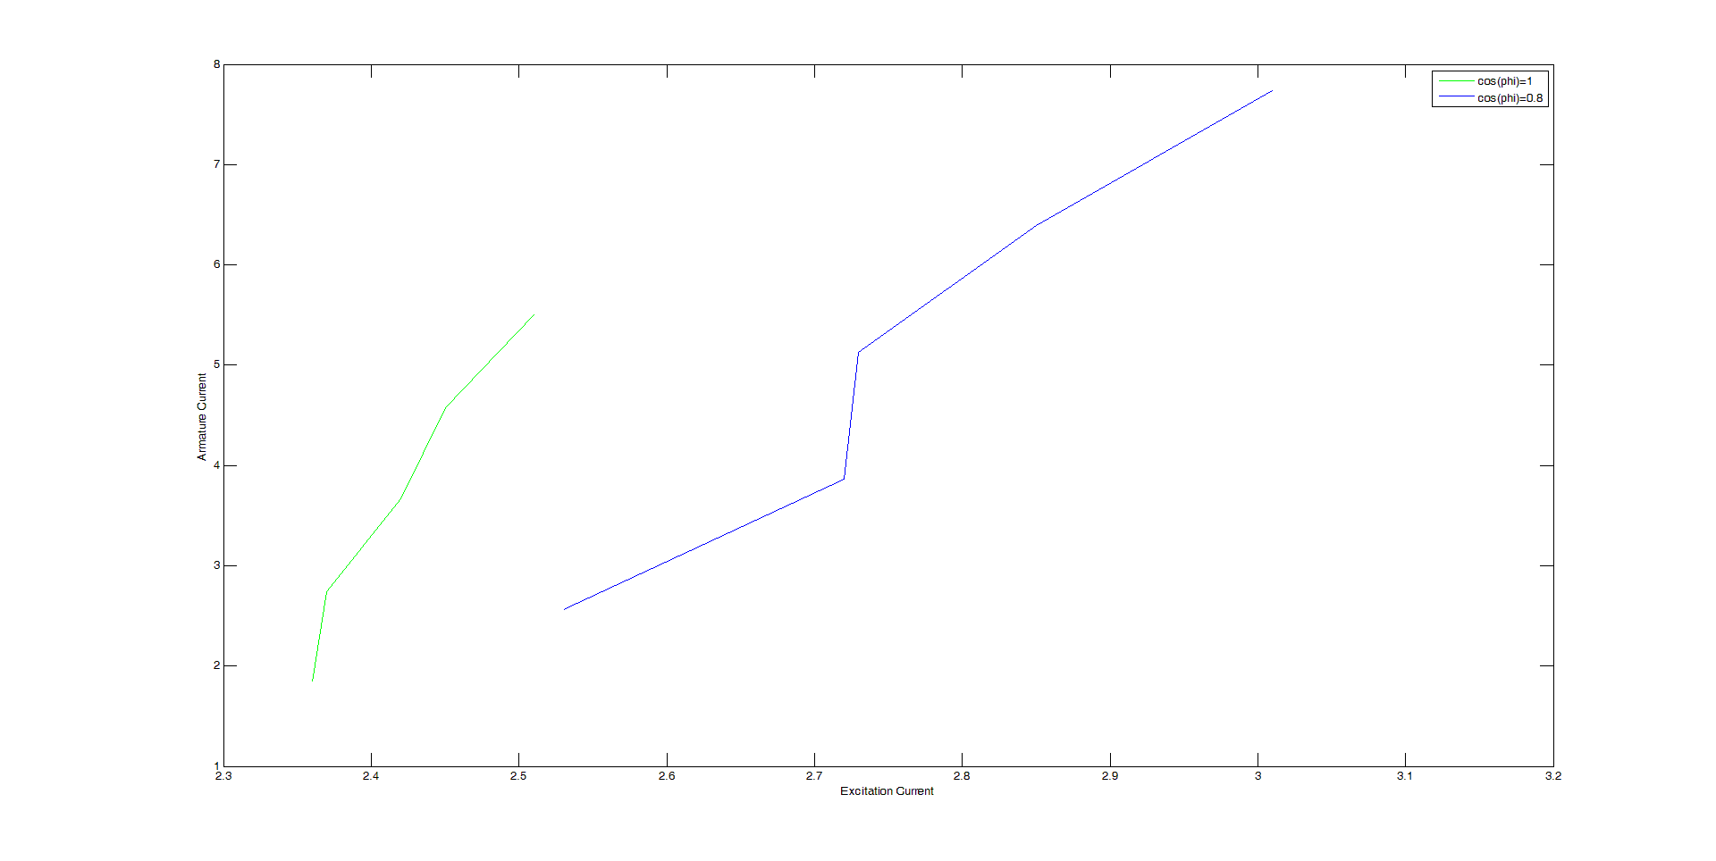

Fig. 2: Adjustement Curves of a Synchronous Generator

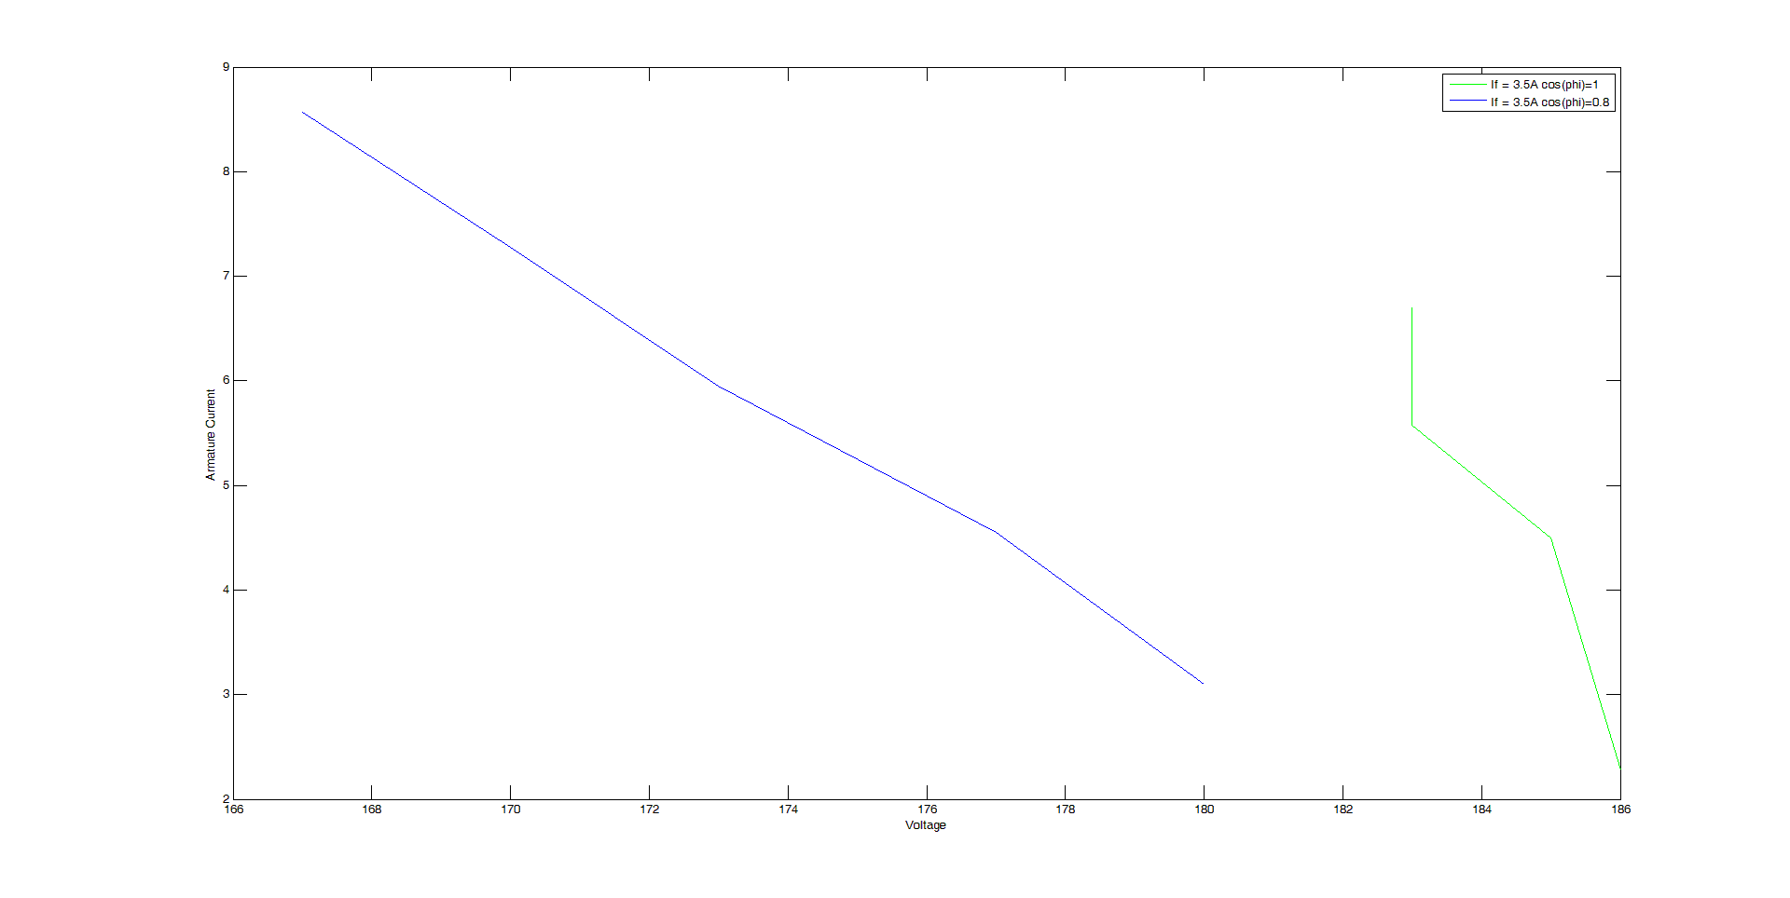

Fig. 3: Outer Characteristics Curves of a Synchronous Generator